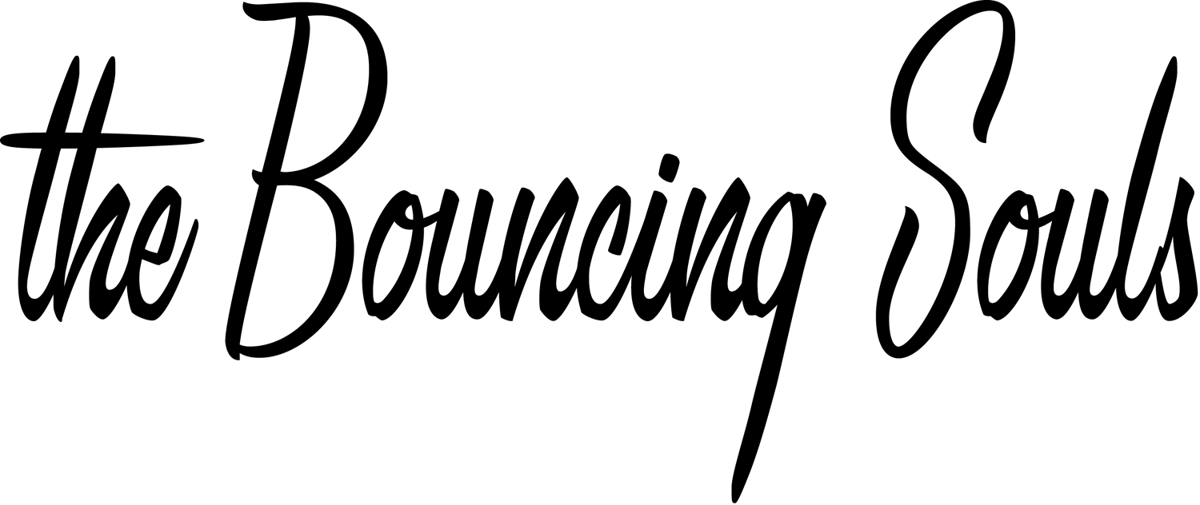
Greg Attonito - Vocals
Michael McDermott - Drums
Papillon- Bass
The Pete- Guitars

We’ve all grown up together. Some came as confused kids; girl-crazy, bike-riding, beverage-drinking adolescent punx. We wrote songs about your mom, about our ramshackle overcrowded dwellings, about not having enough money to pay the rent. Then came the continuous touring years…on the road in an old van with all of our childhood heroes, new found comrades, each other, and our maturing (ahem) thoughts and emotions (and of course the maniacal laughter!). The songs got deeper, longer, stronger, harder, softer, and the Souls sound defined itself on those long rides, endless shows, and the exaggerated bits that happened in short bursts at home on the mighty and proud east coast. We migrated, by twos, by threes to the big city and the big stage. Love became something deeper and lasting, parties became gatherings instead of escapes, home became a feeling instead of mortar and wood, and the songs kept coming, saving us and holding out hands to people out there living parallel desires, heartaches, and trials. They came along with us, the army of hopeless romantics…they stayed by our sides, the true believers...and then they came along on our summer vacation lamenting lost loves, changed dreams, and alternate realities.

The Bouncing Souls have been proud of our entire journey; good and bad, lost and found, hardcore and mid-tempo. We climbed mountains, short stretches at a time, starting out by pressing our own 7”s on Chunksaah, moving into the BYO Records house for our growing pains, and finally to Epitaph where the last three releases (‘The Bouncing Souls’, 1997, ‘Hopeless Romantic’, 1999, and ‘How I Spent My Summer Vacation’, 2001) find us growing popularity, legendary tours, and encouragement. What were once a series of basement shows became a steady stream of gigs with legends like 7 Seconds, The Descendants, and NOFX, heaping spoonfuls of Warped shows, and then pirate journeys with the likes of Flogging Molly and Alkaline Trio. (Oh no, we’re not afraid to mix up the sounds and the philosophies…the more the merrier.) The family proper has ebbed and flowed, all of us shedding our skins to find someone pulling the last bits of tail off in aid…growing into bleeding hearts and artists alike, smiles and tears along the way. And it shows…the music only gets surer, the family happier, and the life better…all crowd-surfing on the steady hands of our fans.

(over)

The next record, entitled ‘Anchors Aweigh’ puts a semi-colon in the sentence that is The Bouncing Souls. It squarely defines what came before and what is to come. There is a maturity, an honesty, a wealth of emotions, personal journeys, and musicianship that sets this collection apart from those before it. Don’t get us wrong, those songs and albums are great, but still stepping stones on our mountain. All of the boys have stepped up to the plate on this at-bat…the unwavering and innovative backbone of Michael McDermott’s drumming, the double and triple guitar tangents from The Pete, the exploring and intemperate power of Bryan’s bass lines, topped off with the one-two punch of singer Greg Attonito’s classic sound, whether shouting or crooning. It is a home-run derby indeed, and Bryan’s pinch-hitting vocals on two selections catching even another curve. These songs are drawn from the deepest parts of our souls…testaments to our intertwinings and unravelings…odes to our journeys and our dreams. It is a journey, mostly by motorcycle (“Night Train”), some not of this earth (“Simple Man”), to the darkest depths of our souls and then plunging out into the everlasting great hope. From the rip-roaring start of “Apt. 5F” to the lamentations of “Kids and Heroes”…from the outcry of “Born Free” to the pleading of “Blind Date”, the heart-breaking loss of ‘Todd’s Song” to the sheer joy of 'Sing Along Forever”, from the ripping of “New Day” to the shredding of “Highway Kings”, the devastation of “The Day I Turned My Back On You” to the promise of the “Anchors Aweigh”..this emotional rescue is complex, moody, pensive, and true. The songs are more developed, not just lyrically, but a sound beneath the surface ever growing, ever-building on what we found that was good and made last. It has brought us to a plateau with a lovely view that we’d love for you to come around and share. Just as it has ours, may rock save your ever-loving bouncing soul.



